LAB 4: PROGRAMS ON METHOD AND CONSTRUCTOR OVERLOADING

Name: Shreyas Sawant Div: D7A Roll No.: 55

Q.1 Consider a class Figure and overload the function called area() to display the area of figures like square,triangle, Rectangle and circle.

CODE:

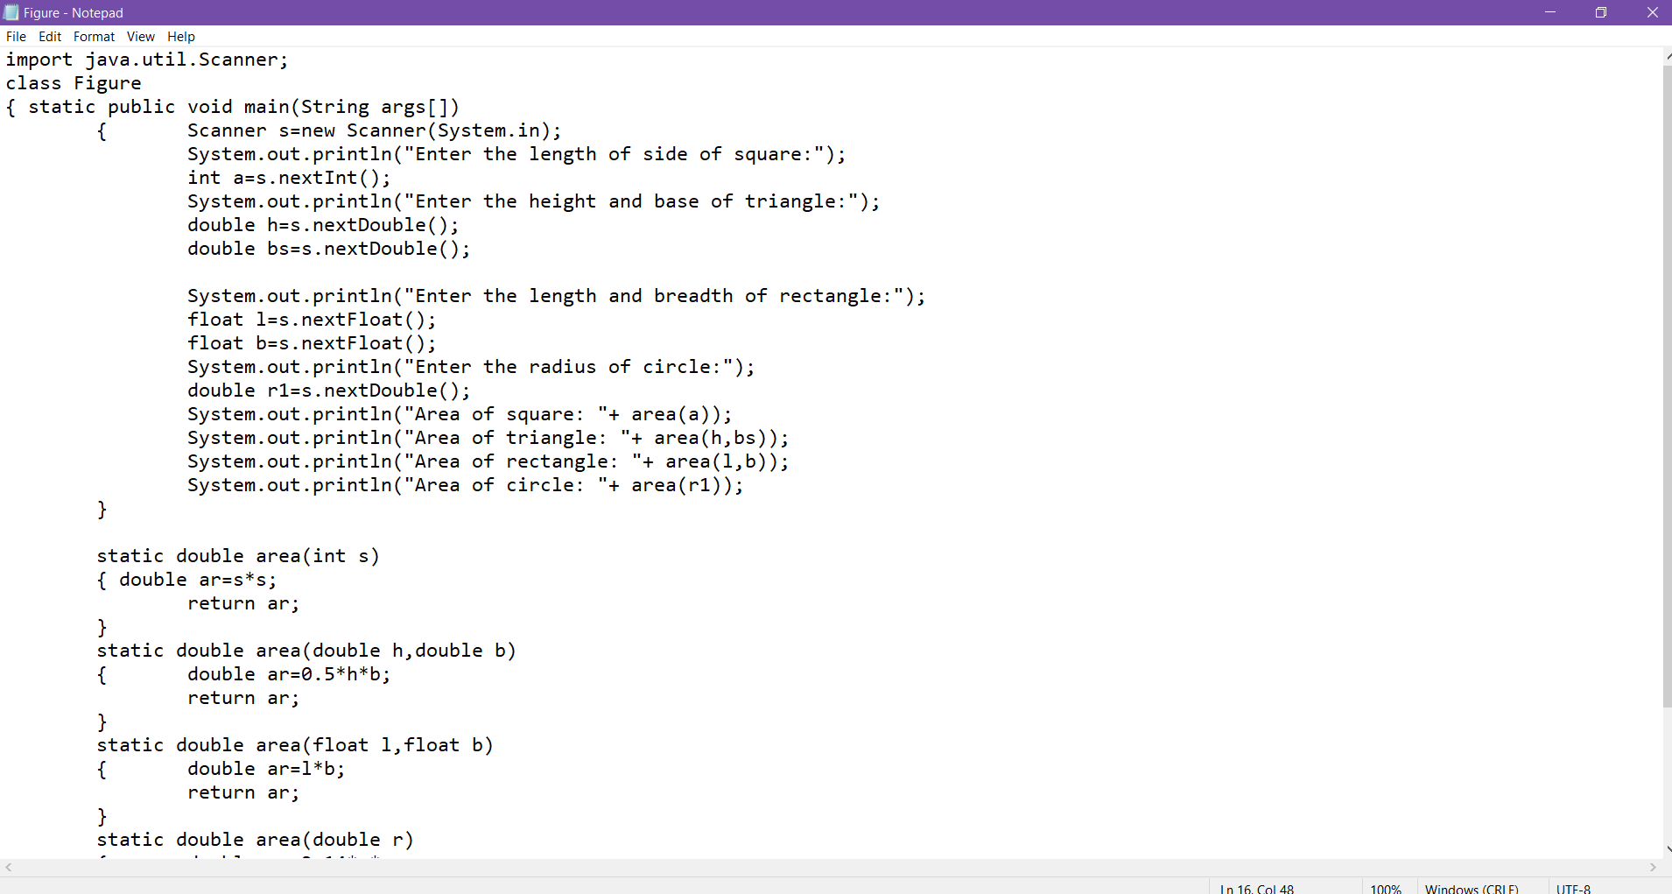

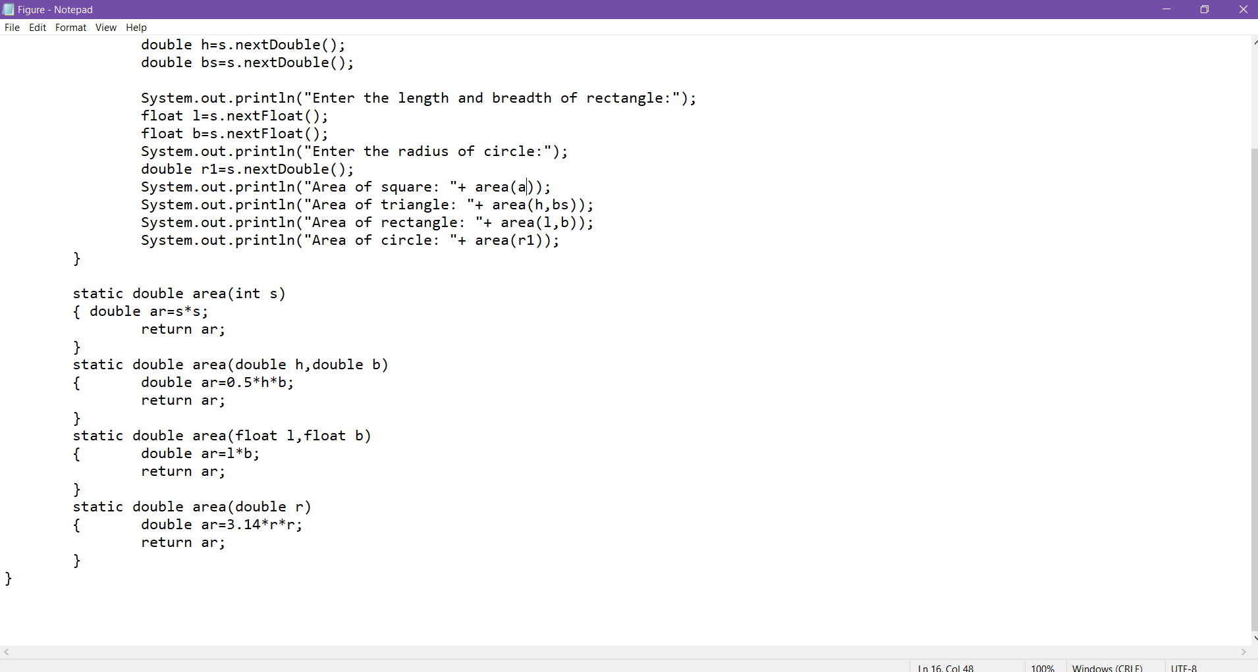

OUTPUT:

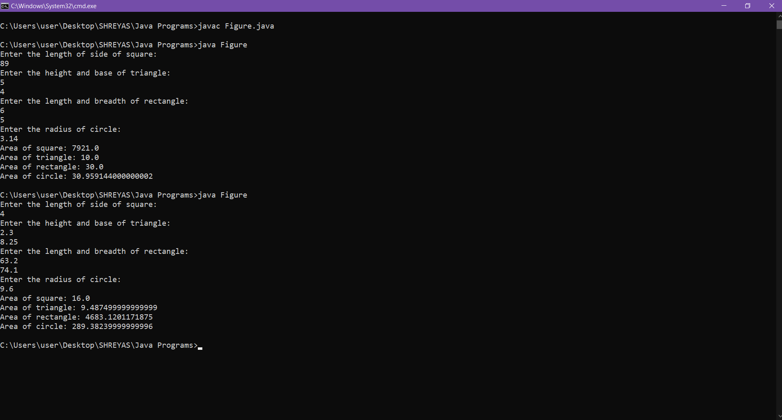

Q.2 Write a Program for Complex Number addition using Constructor.

CODE:

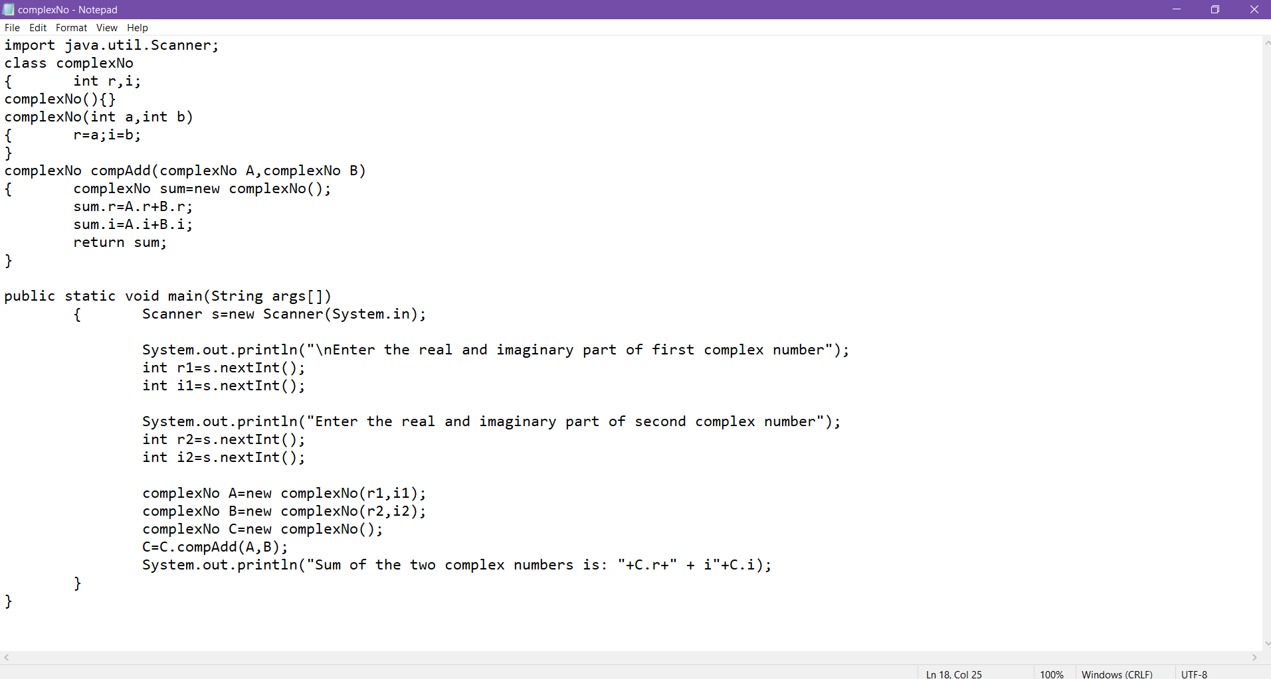

OUTPUT:

